Project presentation - Milestone 0

# Introduction

Our company’s name is ‘Placido & Bravo Bulls’. We are specialized in monitoring data at a given place, mainly with environmental purposes. In this project’s case, we will be monitoring the UVic-UCC “Torre dels Frares” campus.

We are going to capture five different types of different data:

* Exterior Air Quality
* Grass’ conditon
* Interior air quality
* Container fullness
* Parking lots availability

Next, we will store it in a database and finally display it in both a web-based dashboard and a Telegram Bot.

# Objectives

The objectives of our project are divided into two parts:

* Monitor multiple campus data
  + Classroom’s air quality.
* Exterior campus air quality (particles of dust, C02, pollution).
* The conditions of the grass (humidity, temperature).
  + The number of available Parking Sites.
* Container percentage (the rubbish levels).
* Save all the data to a database.
* Develop a Web-based dashboard.
* Develop a Telegram Bot to communicate to the data.

# Roles

After our experience in the university, we designated the roles according to our strengths.

* Martí Vizcaino: Project manager and website developer
* Arnau Tomasa: Mechanical and infrastructure engineer
* Roger Enguídanos: Electronical engineer and assistant code developer
* Roger Colomer: Software engineer

Consider that these roles are flexible, and every team member is going to help in every task.

# Management tool

The tools to be used during the project to ensure the right collaboration and communication of all the participants are the following:

* GitHub: Project management, code repository and documentation
* Microsoft Teams: Sharing information and communication

To ensure the right development of the different project tasks, a follow-up meeting will be held twice a week with the following objectives:

* Explain the status of the already finished tasks and the ones to be initiated
* Raise upcoming risks
* Raise conflicts

# List of material

Exterior air quality:

* Multi-function environmental Module (CO2, temperature, air humidity)
* Ground humidity sensor
* Node MCU ESP8266

Interior air quality:

* Multi-function environmental Module (CO2, temperature, air humidity)
* Node MCU ESP8266

Container fullness:

* Proximity sensor / Ultrasonic Sensor
* Node MCU ESP8266

Parking lots availability:

* Distance Ranging Sensor
* Node MCU ESP8266

Infrastructure:

* Rasbperry pi 4
* SD card 32Gb
* Wifi API (TP-Link)

# Architecture

In this project we will use a microcontroller (similar to ESP8266) for each node. The necessary sensors will be connected to measure the desired parameters in this documentation.

These devices will be connected via WiFi to an Access Point to transmit data to the server via cable. An APi REST will be used to make the inserts into the database to control the flow of incoming data. There will also be a Grafana service installed on the server that will connect directly to the database to represent the data as a function of time. There will also be a telegram bot that will make the SELECTS in the database based on the queries made in it.

The database that will be set up will be a MariaDB server, as it is an open source and includes the necessary features in our project.

Figure 1: Arquitecture of the 


Figure 1: Arquitecture of the project

# Gantt

We have developed a Gantt diagram to organize the tasks. Consider that this is a theoretic, flexible schedule and it may vary during the development of the project.

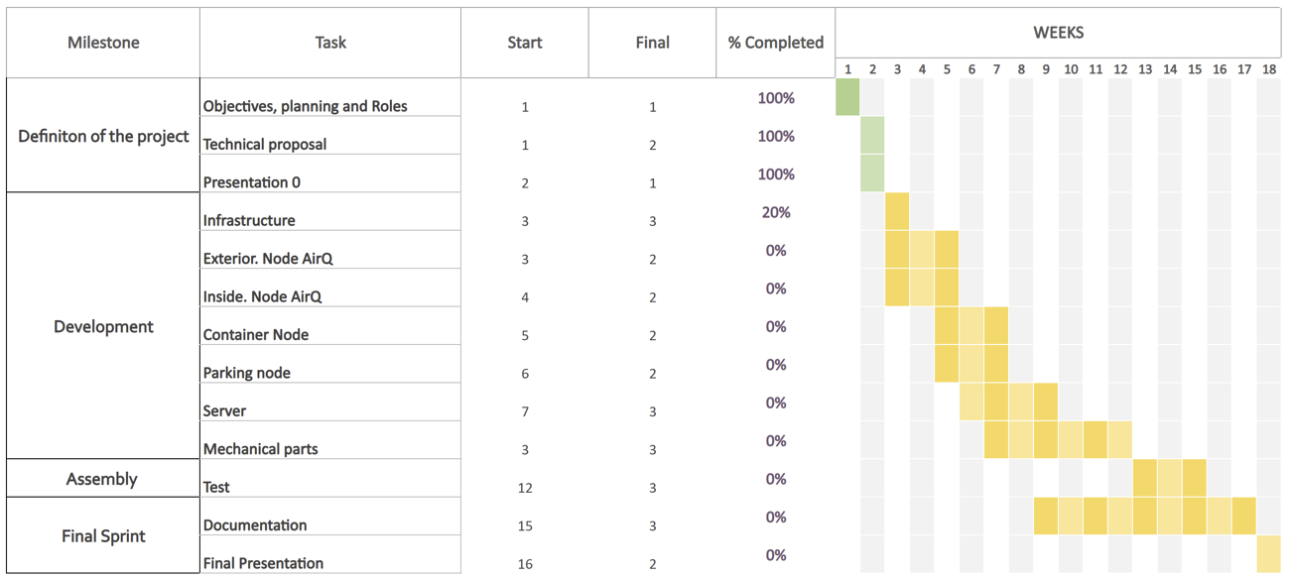

Figure 2: Gantt diagram